Gainful Employment Information

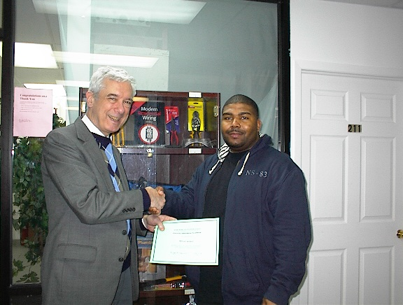
A student receives an award for
Academic Excellence.

Berk Trade and Business School was established in 1940 and has been educating New Yorkers to join the building trades for more than seven decades. To comply with current federal requirements, we are disclosing information related to Gainful Employment.

Occupations Trained for: CIP Codes SOC Codes
(Link to BLS Information)

Comprehensive Plumbing 46.0503 47-2152
Electrical Installation 46.0301 47-2110

Award Provided: Diploma

Program Length:
(The School operates on a Program calendar.)
Comprehensive Plumbing 7.5 months 30 weeks 600 Hrs.
Electrical Installation 7.5 months 30 weeks 600 Hrs.

Graduation Rate:

Comprehensive Plumbing *85%
Electrical Installation *84%
*includes students who completed the program within 150% of program length.
(For the most current information, please contact the School at 718-729-0909.)

Cost for Normal Completion:

Tuition and fees: $11,600.00
(includes books, tools and all other fees.)
The School does not provide on-campus housing. Information about local housing costs can be obtained from Campus Navigator: http://nces.ed.gov/collegenavigator/

Placement Rates (based on last report to the School’s accrediting body)

Comprehensive Plumbing 78%
Electrical Installation 82%

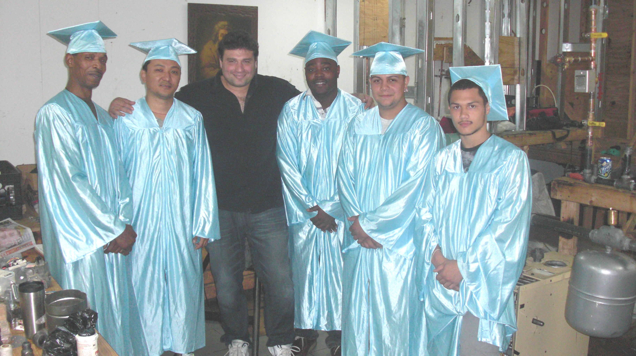
A group of students on Graduation Day.

Additional Services Offered by the School:

- Remedial Services
- Counseling (by a licensed Counselor)
- Placement Services
- Tuition Payment Plans
- No Housing is available at the School

Median Debt Figures
Title IV Loan Program

Comprehensive Plumbing $6,333
Electrical Installation $6,333
The School does not provide loans beyond the cost of tuition and does not offer institutional loans.

Financial Aid is available if you qualify. Approximately 75% of Berk Trade and Business
School students receive financial aid. Students fill out a FAFSA form. Aid varies by
various factors that are best discussed with a Financial Aid representative at the School.

Net Price Calculator Information
(Also available at IPEDS)

Based on 2012-2013 Data Provided to IPEDS:

Tuition & fees $11,350

Books and supplies $250

Off-campus

Room and board $10,125
Other expenses $1,875

Off-campus with family

Other expenses $2,063

